Stage 3 - 2022
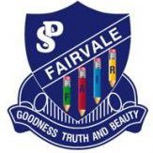
Welcome to Stage Three at Fairvale Public School. We are looking forward to a wonderful year working with you and your child as well as forming and maintaining productive home-school partnerships. Below you will find an overview of the key learning areas that your child will be engaged in daily.
Key Learning Area Overview
English | English is taught for 8 hours per week. Students participate in a range of reading, writing and speaking activities.
Mathematics | Mathematics is taught for 5 hours per week. Students participate in a range of lessons throughout the year including number and algebra, measurement and geometry and statistics and probability,
Science & Technology | Science and Technology is taught for 1.5 hours per week. In term 1 students will be learning about Earth & Space.
Geography | Geography is taught for 1.5 hours per week. In semester 1, Year 5 students will be learning about Factors that Shape Places and Year 6 will learn The Diverse and Connected World
History | History is taught for 1.5 hours per week. History will be taught in semester 2.
PDHPE | PDHPE is taught for 2.5 hours per week. Students participate in a range of activities including movement skills and performance, healthy safe and active lifestyles, including E-Safety.
Creative Arts | Creative Arts is taught for 1.5 hours per week. Students participate in a range of activities including dancing, drama, music and visual arts.

General information
Stage 3 Assembly | 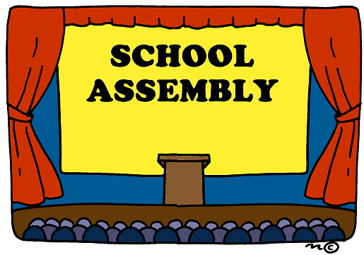  For Term 1 Friday 10am  (Due to COVID-19 Assemblies are different. We will update you as things change)
Crunch and Sip | Daily at 10am.  Please pack fresh fruit or vegetables in your child’s lunch.
Religious Education Instruction | Monday 2:30pm – 3pm
Sports Day | Friday 2-3pm
Library | Tuesday
Keep up to date with school news and events!
School App | School Website | Like us on Facebook | Follow us on Twitter | Class Seesaw
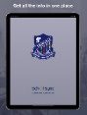  Search for Fairvale Public School and download our free application. | Take a look at our school website.  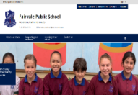  https://fairvale-p.schools.nsw.gov.au/ | 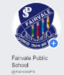  Search for Fairvale Public School on Facebook @FairvalePS. | Follow Fairvale Public School on Twitter @FairvalePS | Login to your child’s Seesaw account.

5/6 Dugongs 2022
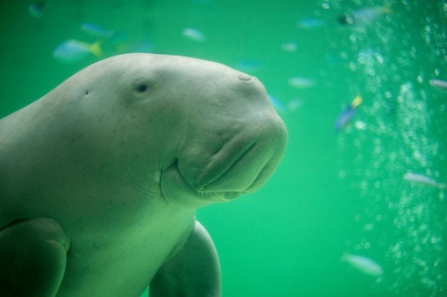

Welcome to 5/6 Dugongs in 2022! My name is Miss Ramina David and I cannot wait to see what 2022 brings for everyone in 5/6 Dugongs. I look forward to working with you and supporting your child in achieving their very best. This year our classes at Fairvale are named after sea animals, 2022 is the year of Artisanal Fisheries and Aquaculture!

Attendance | It is very important that all students attend school every day, however, we understand if your child is sick or there is an emergency. It is essential for children in their final year of primary schooling to attend school as much as possible. If your child is away please ensure you either call the office to inform us or send a note with your child on the next day that they are at school. This note needs to be returned within 7 days of the absence.
Concerns | I understand that good communication is an important part of your child’s success. If there is anything you need to discuss or if you have any questions, please feel free to come and see me after 3:00pm. Alternatively, you could call the office to arrange a time to meet or you can contact me directly through Seesaw.
Reading Eggs and Mathletics | We will continue to have access to both Reading Eggspress and Mathletics this year. Each student will be given a log in for each program. We will do some of these activities at school as well as including some activities as part of the homework program.
Names on belongings | Please ensure your child’s belongings have their names on them. We strongly encourage all students to wear a school hat every day as well.
Homework | Homework will be given at the beginning of every fortnight. Students have 2 weeks to complete their homework. Homework should be returned every second Friday. It is also encouraged that students participate in home reading every night and complete the reading log sent home.
Sports clothes on Friday | It is our sport day on Fridays so please ensure that your child is wearing their sports uniform. This will include white joggers for them to run in. If your child is selected to play in a PSSA team, a school hat is required for them to be able to participate.
Notes Home | Students are encouraged to return all signed notes to school requiring permission to participate in school events, such as excursions and incursions.
Seesaw | We will be sharing our learning in 5/6D using Seesaw. Each child will have their own account which you can simply download on your phone if you have already not connected. You will be able to see pictures of learning, work samples and special events. I will also contact you through Seesaw so please check often.
