Stage 1 - 2022
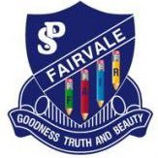
Welcome to Stage One at Fairvale Public School. We are looking forward to a wonderful year working with you and your child as well as forming and maintaining productive home-school partnerships. Below you will find an overview of the key learning areas that your child will be engaged in on a daily basis.
Key Learning Area Overview
English | English is taught for 8 hours per week. Students participate in a range of reading, writing and speaking activities.
Mathematics | Mathematics is taught for 5 hours per week. Students participate in a range of lessons throughout the year including number and algebra, measurement and geometry and statistics and probability,
Science & Technology | Science and Technology is taught for 1.5 hours per week. In term 1 students will be learning about Living World.
Geography | Geography is taught for 1.5 hours per week. In semester 1, Stage 1 students will be learning about People and Places.
History | History is taught for 1.5 hours per week. History will be taught in semester 2.
PDHPE | PDHPE is taught for 2.5 hours per week. Students participate in a range of activities including fundamental movement skills, nutrition, road safety, keeping safe and physical education lessons.
Creative Arts | Creative Arts is taught for 1.5 hours per week. Students participate in a range of activities including dancing, drama, music and visual arts.

General information
Stage 1 Assembly | 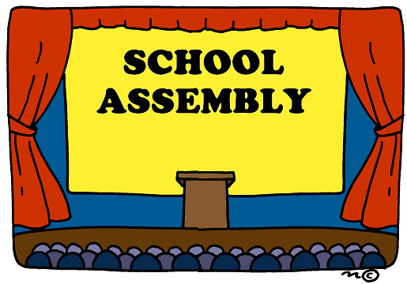  For Term 1: Friday 11:45am (Due to COVID-19 Assemblies are different. We will update you as things change)
Crunch and Sip | Daily at 10am.  Please pack fresh fruit or vegetables in your child’s lunch.
Religious Education Instruction | Monday 1:30pm – 2pm
Sports Day | Friday 9-10am
Library | Friday
Keep up to date with school news and events!
School App | School Website | Like us on Facebook | Follow us on Twitter | Class Seesaw
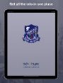  Search for Fairvale Public School and download our free application. | Take a look at our school website.  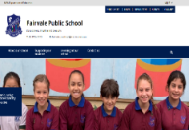  https://fairvale-p.schools.nsw.gov.au/ | 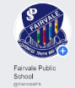  Search for Fairvale Public School on Facebook @FairvalePS. | Follow Fairvale Public School on Twitter @FairvalePS | Login to your child’s Seesaw account.

1 Emperor Penguins 2022

Welcome to 1 Emperor Penguins in 2022. My name is Miss Erica Nak and I am the classroom teacher for 1 Emperor Penguins (1E). I cannot wait to see what 2022 brings for 1 Emperor Penguins. This year our classes at Fairvale are named after sea animals, 2022 is the year of Artisanal Fisheries and Aquaculture! Emperor Penguins are the tallest and heaviest penguins. They can live up to 15-20 years!

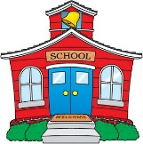  Attendance | It is very important that all students attend school every day, but we understand if your child is sick or there is an emergency. However, it is essential for children in their first year of schooling to attend school as much as possible. We do many important activities that will benefit students through the rest of their schooling. If your child is away, please ensure you either call the office to inform us or send a note with your child on the next day that they are at school. This note needs to be returned within 7 days of the absence.
Concerns | If you ever have any concerns regarding your child whether that be academic or not, please feel free to come and see me. I will endeavour to solve your concern or provide you with the information you need. I may need to book a time to meet you, either to find out the correct information or to sit down and discuss your concern properly.
Reading Eggs and Mathletics | We are lucky enough to have access to both Reading Eggs, for English and Mathletics, for Mathematics. I will provide each student with a log in for each program. We will do some of these activities at school, however, if you would like to work with your child at home, that would be extremely helpful.
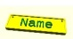  Names on belongings | Please ensure all of your child’s belongings have their names on them. We often have hats and jumpers without names on them and they go missing. With winter coming up please make sure that you label everything!
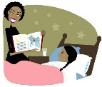  Home Reading | Each week we will send books home with students. This is an excellent opportunity for you to read an appropriate book with your child. Books will need to be returned every Monday/Wednesday and Friday. Please ensure that you return the books on these days so we can swap the books. Children can swap their books daily if they want.
Sports clothes on Friday | It is our sport day on Fridays so please ensure that your child is wearing their sports uniform. This will include white joggers for them to run in.
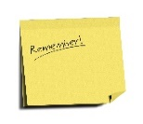  Notes Home | I will send all notes home inside your child’s bag. Please check this regularly, we are a very busy school and we will often send notes home with important information. This will also include our school newsletter which is sent home every fortnight.
Tuesday afternoon | On Tuesday afternoons from 2-3, I will have professional learning. This is where I will meet with other teachers and we are taught different strategies to better the learning of the students. Mrs Buenaventura will take 1E during this time.
Library Bags | On Friday afternoons, 1E will have library with Mrs Orwin. Please make sure your child brings a library bag so they are able to borrow books.
Seesaw | We will be sharing our learning in 1E through the use of Seesaw. Each child will have their own account which you can simply download on your phone, if you have not already connected. You will be able to see pictures of learning, work samples and special events. I will contact you regularly through Seesaw so please check often.
